# QLA demo set up

## Data:

* QLA_summary_breaks – used for the dashboard page of the VA report
* QLA_measurement_data – used for the rest of the reports and analysis

## Changes required:

* 2 packages are included in the zip file, containing the VA report & exploration and also the stored processes. I have included all dependent objects but I am not sure if this helps. You may need to map links to data, libraries manually.
* Links to Scatter plot & XR chart will need updating on the front page of the QLA VA report
* Scatter plot & XR plot stored processes, will require the libname updating in the code to the location where the data is registered.

## Assets

1. QLA exploration – VA exploration

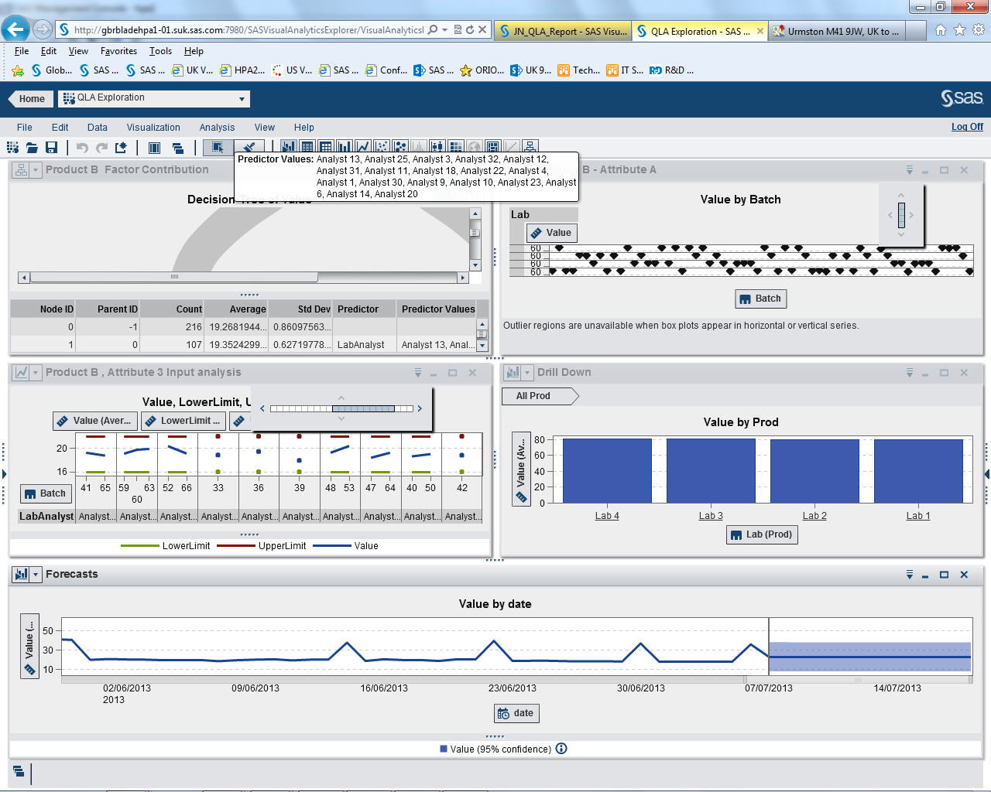

1. JN_QLA_Report – VA report

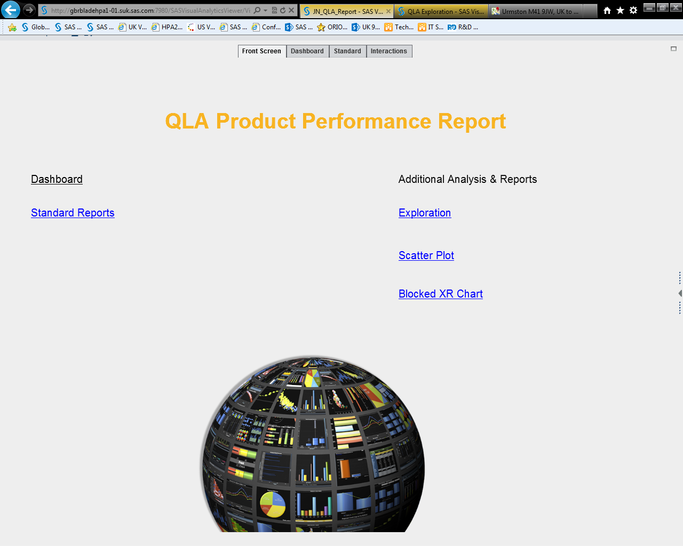

1. Scatter plot - stored process

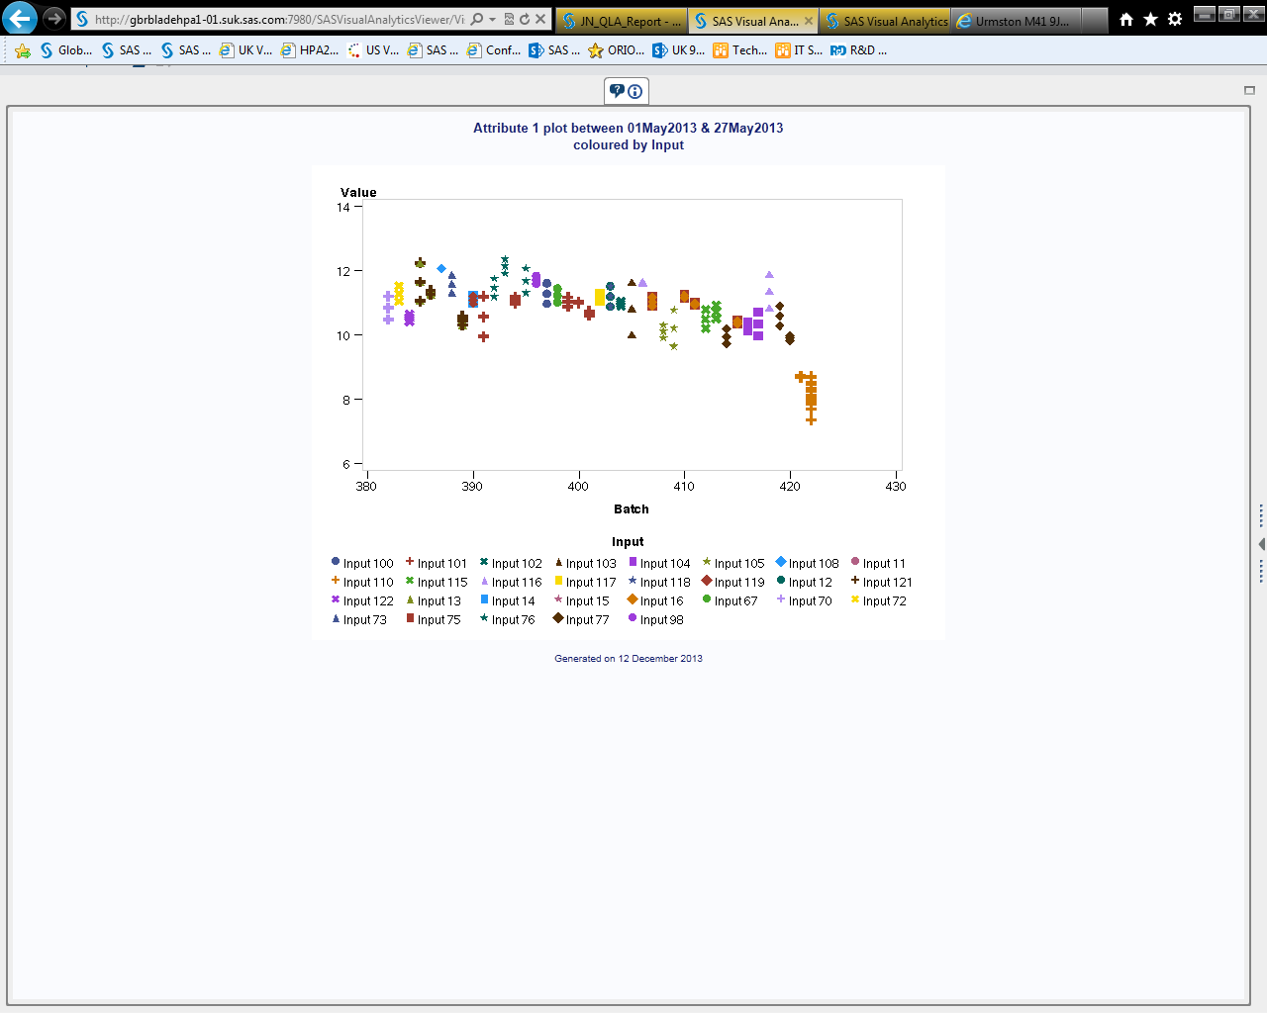

1. XR Chart - stored process

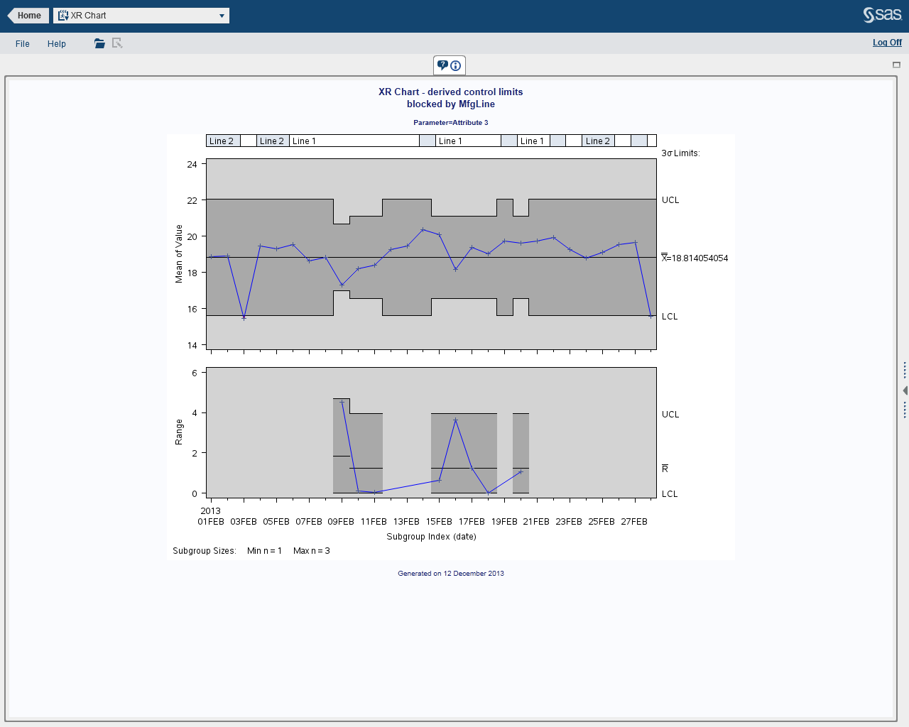

1. QC demo Project - Enterprise Guide project

